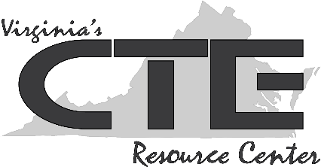
Teacher Resource #1:
Common Interview Questions

What are your strengths/weaknesses?
Why should we hire you?
Why are you job searching? Why are you/did you leave your last job?
What are your career goals, and how does this job relate to them?
Where do you see yourself in five years?
What is an accomplishment of which you are proud? Explain.
Describe how you handled a challenging situation at work.
How might you deal with an angry customer/client?
What is an area for improvement for you?
How do you feel about professional development?
What are some strategies you use to stay organized?

